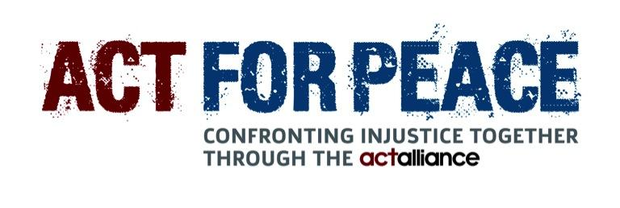

Media Release May 2021

Why Experts Say Charitable Fundraising is Good for Kids

Since COVID-19 rocked our world, children have been exposed to the pain and suffering of others. Even if we turn off the television, young children have experienced first-hand the effects of lockdowns, mask-wearing, social isolation and worried conversations. While here in Australia, we are living our ‘new normal’, there are 665,834 registered refugees living in in Jordan who continue to suffer. Already struggling to survive, they are grappling with the devastating impact of the pandemic. By reaching out to help, Australian children and families can learn the value of empathy and making a difference in the world.

The Ration Challenge is a powerful and thought-provoking fundraising initiative that empowers Australian children and their families, teachers and class-mates to stand in solidarity with children who are living as refugees in other countries. Every family or school student registered by their teacher will receive a ration pack in the mail, containing the same rations, in the same quantities, as those distributed to Syrian refugees in camps in Jordan – just a small amount of rice, beans, chickpeas, lentils, fish, oil and flour.

More than 99,000 people have taken part in the Ration Challenge since it was first launched in 2014, and more than $19 million has been raised to help Syrian refugees and other vulnerable communities around the world, now also dealing with the devastating impact of COVID-19.

Psychologist Kirsten Hunter, said that there are many benefits to children taking part in fundraising activities such as the Ration Challenge:

- Values - charity reminds us of what really matters; being safe, being healthy, being loved.

- Connection - we need one another to survive. Charity is about bringing those with better fortune to be more connected with those with lesser fortune, whether that be financial, health or safety. Connection and a sense of belonging in our world is crucial for our mental health.

- Joy - we find increasing joy in giving and receiving. Actually, when we give, we are also receiving, as it brings us a sense of joy and satisfaction.

- Expanded horizons - charity opens a doorway into other people’s worlds – we can learn about the complexity and the trial of others’ lives. Each of us has our unique life experiences and our stories of courage, joy and pleasure, as well as fear, sorrow and loss. Charity broadens our world.

- Unity - we all have our human needs; different ethnicities, different religions, different cultures, different backgrounds. We are more alike than we are different. We are all in this together. Charity allows us to extend our care globally.

- Compassion - with our over reliance on technology and our fast-paced lives, we can start to feel disconnected from the heart, the pulse, and the reality of people in need. Charity is about being real about other’s needs, and learning to prioritise others. It is vital to teach our children to be caring and mindful of others. We want our children to grow up to be kind and compassionate. Charity is a concrete experience to strengthen these values in our children.

To register, visit: https://schools.rationchallenge.org.au/.

ABOUT ACT FOR PEACE
Act for Peace is the international aid agency of the National Council of Churches in Australia, and empowers passionate people to work together to achieve safety, justice and dignity in communities threatened by conflict and disaster. Act for Peace works with local organisations in over 20 countries across Africa, Asia, the Middle East and the Pacific, providing food, shelter, education, healthcare and training to help some of the world’s most vulnerable communities take leadership in preparing for, responding to and recover from conflict and disaster.

Kirsten Hunter is a clinical psychologist, mother of 5 boys and author of six-book DIY Psychology series, “Signposts for living”. She has accumulated over 42,000 hours of clinical practise and guides her clients to implement effective therapeutic change.

For further information, visit: https://www.kirstenhunterauthor.com/

#Ends. Media information: Deborah Ivison: e: deb@baypr.com.au; t: 0412 007 202.

